INTERNSHALA CAPSTONE PROJECT SUBMISSION
MARKET ENTRY ANALYSIS FOR ABG MOTORS IN INDIA
INTERNSHALA TRAININGS
DATA SCIENCE COURSE
Submitted By
ELUMALAI M
B.TECH- PETROLEUM ENGINEERING AND TECHNOLOGY
ANNA UNIVERSITY
CHENNAI-25
Email-ezhumalai634@gmail.com
TOOLS USED - PYTHON | EXCEL | TABLEAU

S:no | Index
1. | Introduction
2. | Business Problem
3. | Objectives
4. | Dataset Description
5. | Data Cleaning & Preprocessing
6. | EDA / Japanese Market Analysis
7. | Classification Model – Logistic Regression
8. | Model Evaluation
9. | Coefficient & Business Interpretation
10. | Indian Market Potential – 69,289
11. | Tableau Dashboard & Key Insights
12. | Business Recommendation
13. | Conclusion

1.Introduction
ABG Motors is planning to enter the Indian automobile market and needs to understand the potential customer base before making business decisions. This project uses customer data from Japan to build a classification model that predicts the likelihood of car purchase. The developed model is then applied to Indian customer data to estimate the potential market size. Tableau visualisations are also used to analyse customer trends and support business interpretation.
2. Business Problem
ABG Motors wants to enter the Indian automobile market with a target of achieving at least 12,000 car sales per year. Before entering the market, the company needs to identify potential customers and understand the factors associated with car purchase. A data-driven analysis can help estimate the potential customer base and support the market-entry decision.
3. Objectives
The main objectives of this project are:
- To analyse the Japanese customer dataset.
- To identify factors associated with car purchase.
- To build a classification model using Logistic Regression.
- To evaluate the performance of the developed model.
- To interpret the model coefficients from a business perspective.
- To apply the model to the Indian customer dataset.
- To estimate the number of potential customers in India.
- To create Tableau visualisations for market analysis.
4. Dataset Description
Two datasets were used in this project: Japanese customer data and Indian customer data.
Japanese Dataset
- Records: 40,000
- Features: ID, Current Age, Gender, Annual Income, Age of Car and Purchase.
- The PURCHASE variable represents whether the customer purchased a car.
Indian Dataset
- Records: 70,000
- Features: ID, Current Age, Gender, Annual Income and Maintenance Date.
- The Indian dataset was transformed to create the AGE_CAR variable required for applying the classification model.
5. Data Cleaning & Preprocessing
The datasets were checked for missing values and duplicate records. The data was then prepared for machine-learning analysis.
The GENDER categorical variable was converted into a numerical representation using one-hot encoding. The numerical features were standardised using Standard Scaler. The Japanese dataset was divided into training and testing datasets using an 80:20 split. Stratified sampling was used to maintain the distribution of the target variable.
For the Indian dataset, the maintenance-date information was transformed into an AGE_CAR variable so that the same model features could be used for prediction.
6. EDA / Japanese Market Analysis
Exploratory Data Analysis was performed to understand customer characteristics and purchase behaviour in the Japanese market.
The analysis focused on:
- Customer age distribution.
- Annual income distribution.
- Relationship between age and purchase.
- Relationship between income and purchase.
- Overall purchase distribution.
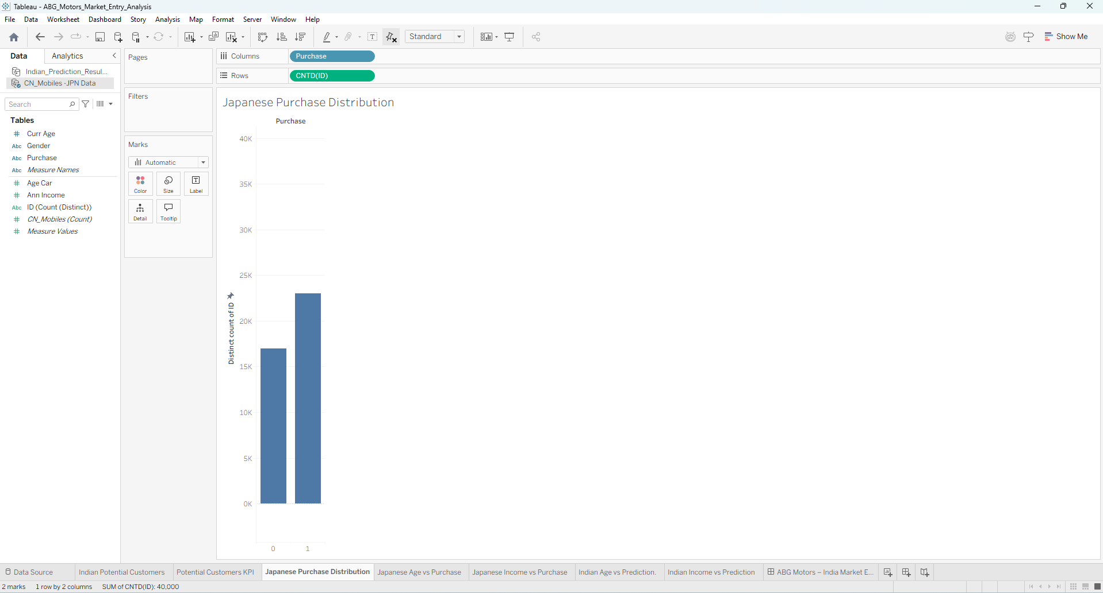
- The visualisations helped identify patterns in customer characteristics and provided an initial understanding of variables that may influence purchase behaviour.
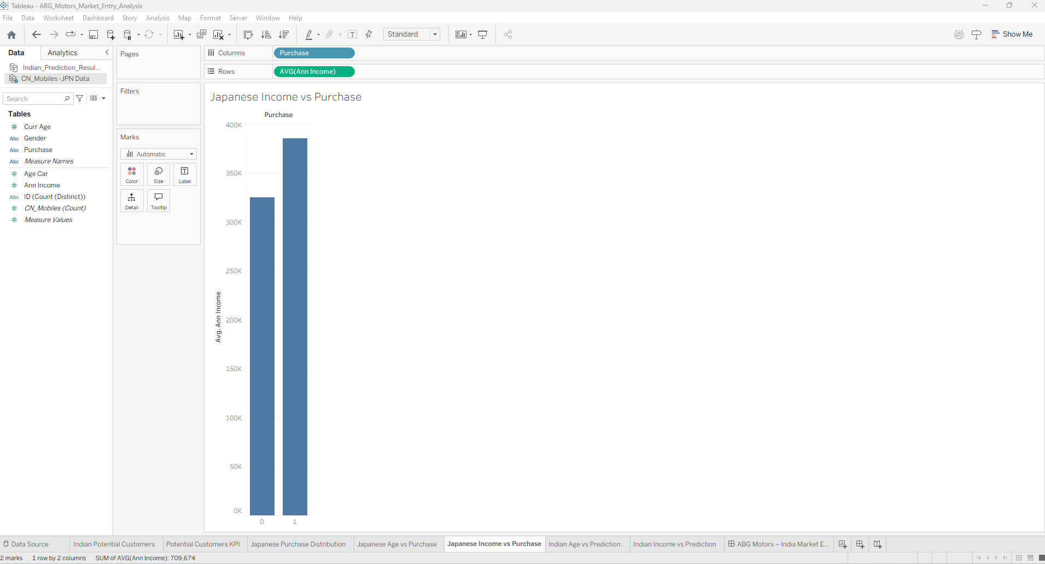
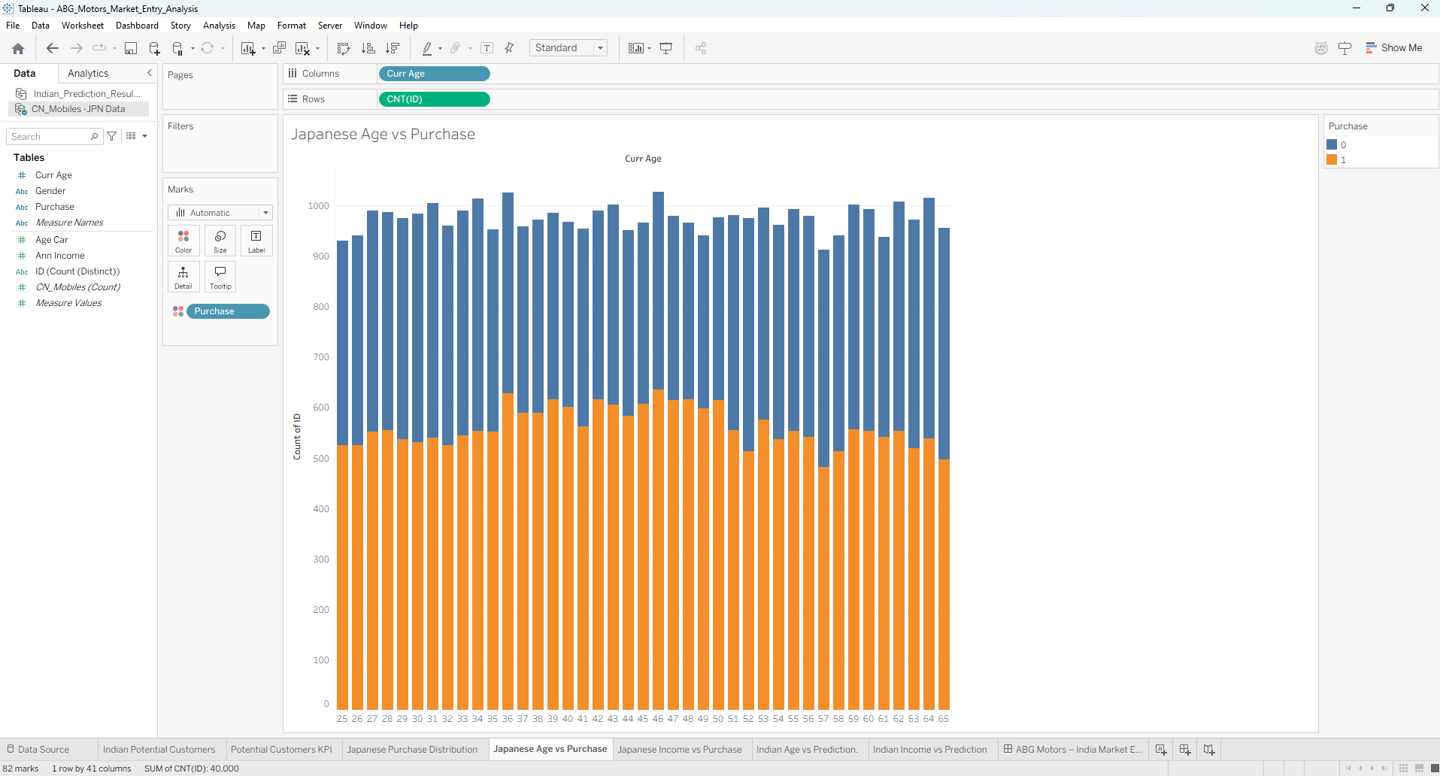

7. Classification Model – Logistic Regression
A Logistic Regression classification model was developed using the Japanese dataset.
The input variables used were:
- CURR_AGE
- GENDER
- ANN_INCOME
- AGE_CAR
The target variable was:
- PURCHASE
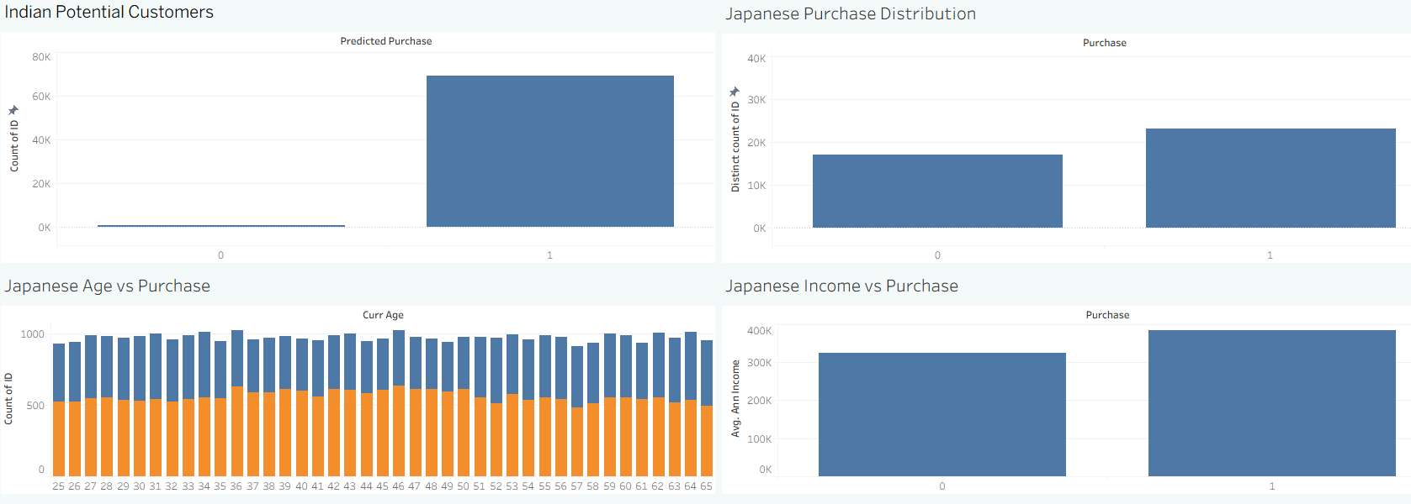
Logistic Regression was selected because the target variable is binary, representing purchase and non-purchase outcomes. The model produces a probability of purchase, which can then be converted

8. Model Evaluation
The trained model was evaluated using the test dataset. A confusion matrix was used to compare actual and predicted purchase outcomes.
The model was evaluated using:
- Accuracy
- Precision
- Recall
- F1-score
- Confusion Matrix

- These metrics were used to understand how effectively the model distinguishes between customers who are likely and unlikely to purchase.

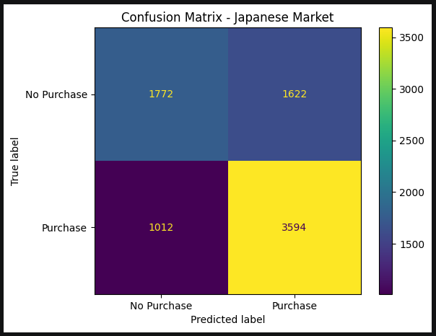

9. Coefficient & Business Interpretation
The coefficients generated by the Logistic Regression model were analysed to understand the relationship between the input variables and purchase likelihood.
A positive coefficient indicates that an increase or presence of that feature is associated with higher purchase odds, while a negative coefficient indicates an association with lower purchase odds, holding other model variables constant.
The coefficients were also converted into odds ratios using the exponential of the coefficient. This provides a more interpretable measure of how the model variables are associated with purchase odds. This provides a more interpretable measure of how the model variables are associated with purchase odds.

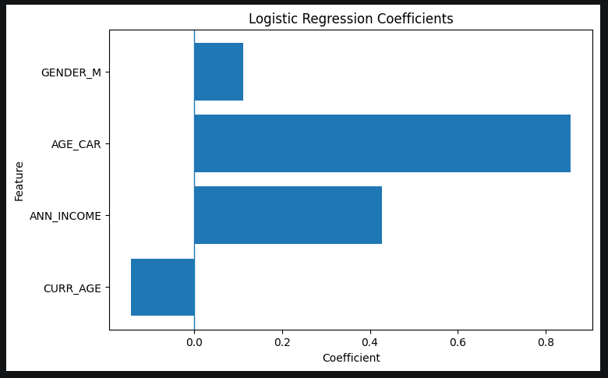

10. Indian Market Potential – 69,289
The trained Logistic Regression model was applied to the Indian customer dataset to estimate purchase likelihood.
The model classified:
69,289 customers as predicted purchasers
and
711 customers as predicted non-purchasers
out of 70,000 Indian customer records.
Therefore, the estimated potential customer count from this model is 69,289.
This represents a model-based potential customer estimate, not guaranteed vehicle sales. The result depends on the model assumptions, data quality and preprocessing method.
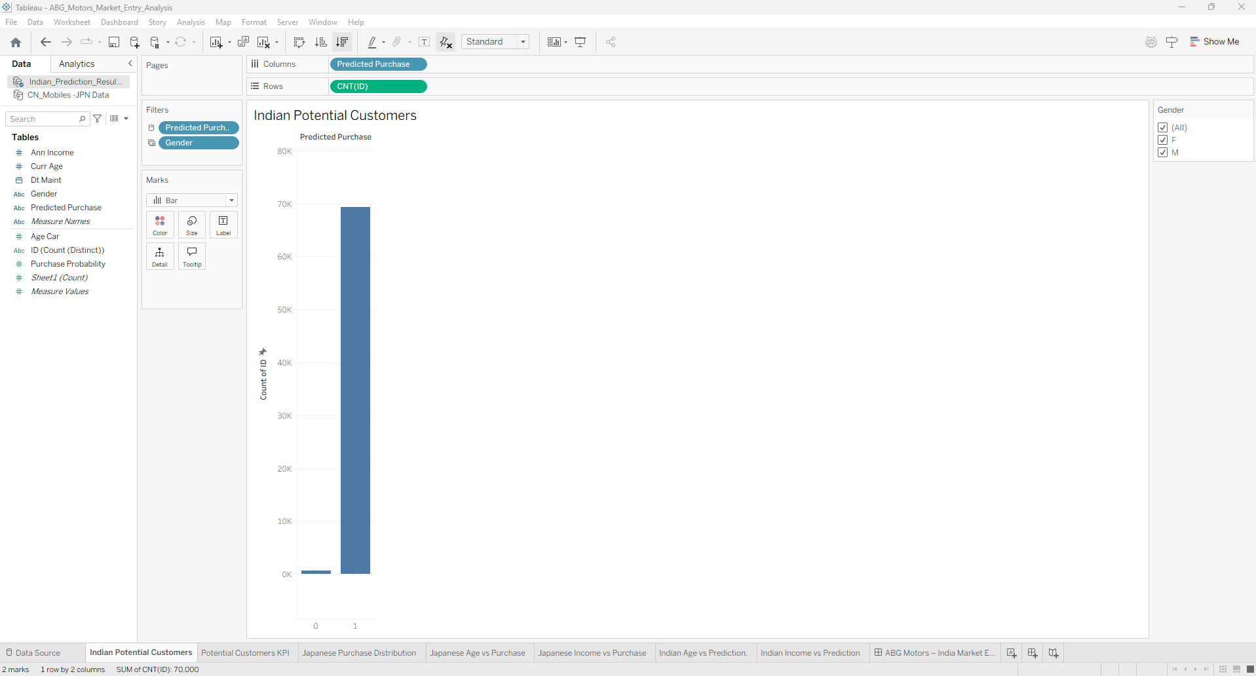
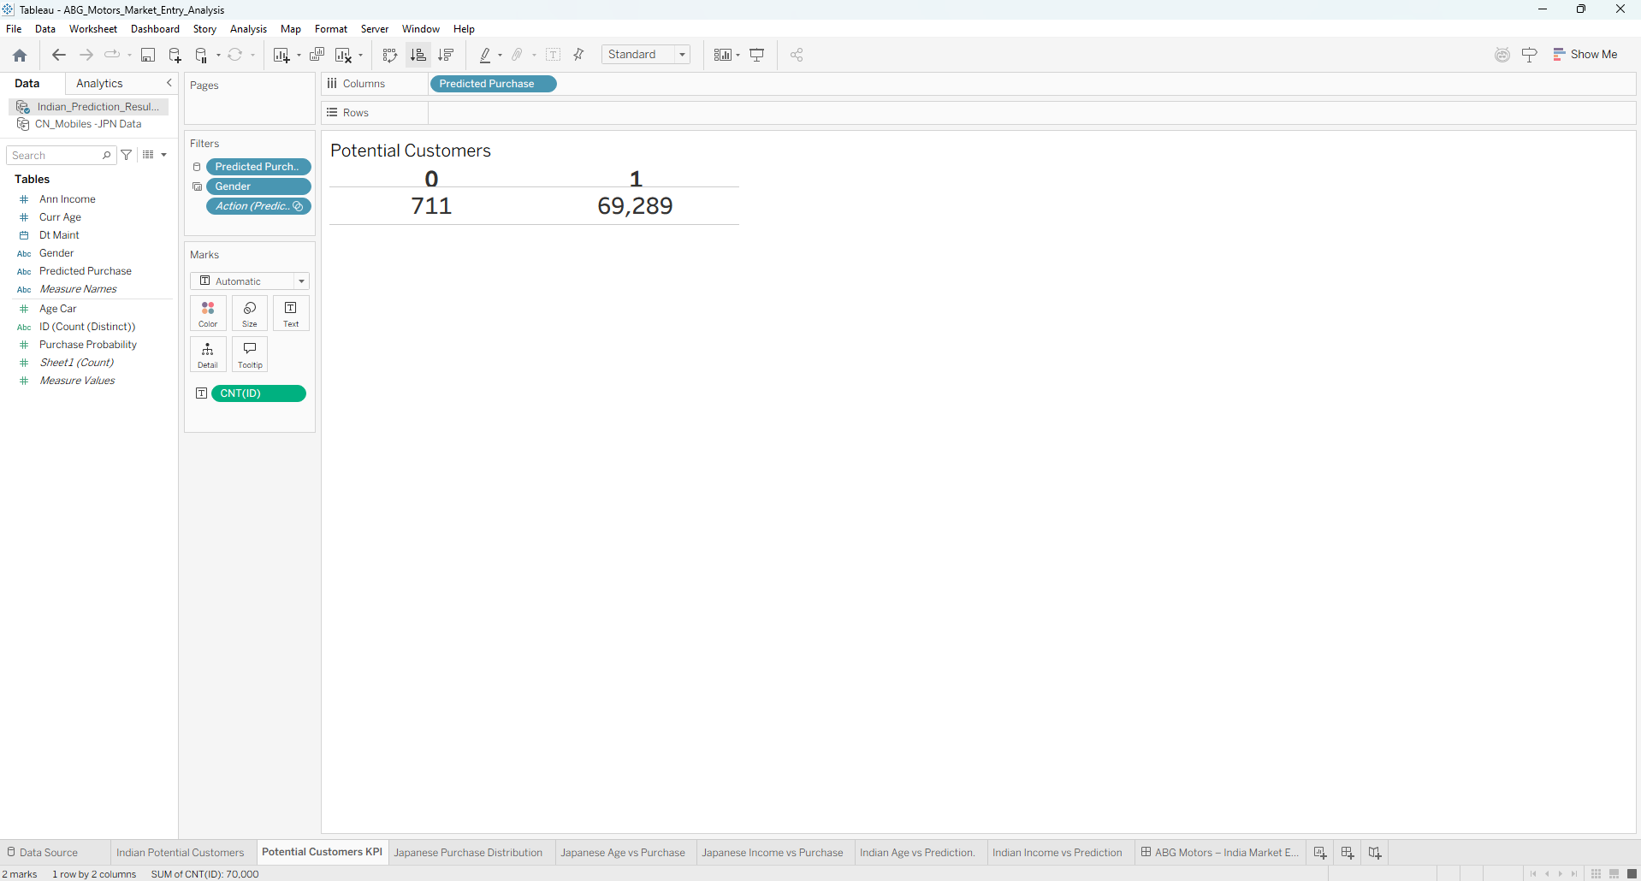

11. Tableau Dashboard & Key Insights
A Tableau dashboard was developed to present the analysis in an interactive format.
The dashboard includes:
- Indian Potential Customers
- Japanese Purchase Distribution
- Japanese Age vs Purchase
- Japanese Income vs Purchase
- Indian Age vs Prediction
- Indian Income vs Prediction
- Predicted Purchase filter
- Gender filter
The dashboard provides a visual comparison of customer characteristics and predicted purchase

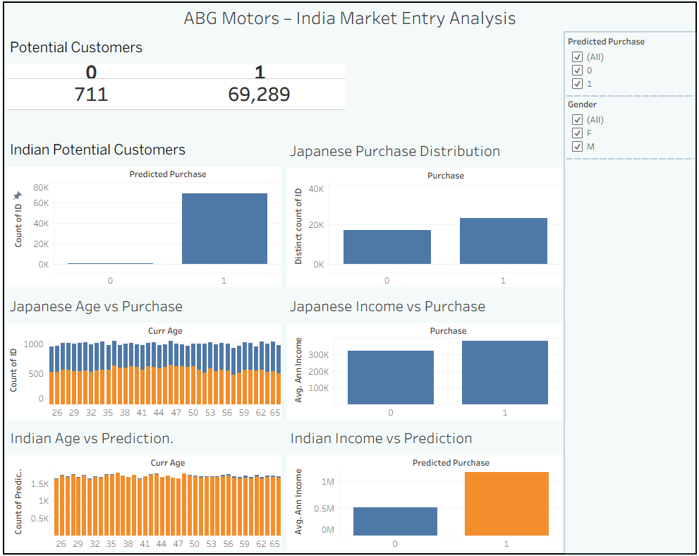

12. Business Recommendation
The analysis provides ABG Motors with a data-driven view of the potential Indian customer base. The model identifies many Indian records as potential purchasers, which can be used as an initial basis for further market investigation.
Before making an actual market-entry decision, ABG Motors should additionally consider factors such as pricing, competition, customer preferences, dealership availability, distribution costs and market conditions.
The model prediction should therefore be treated as a screening and market-analysis tool rather than a direct sales forecast.

13. Conclusion
This project developed a data-driven approach for analysing ABG Motors' potential entry into the Indian automobile market. Japanese customer data was analysed using Exploratory Data Analysis, and a Logistic Regression classification model was developed to predict car purchase likelihood.
The model was evaluated using standard classification metrics and its coefficients were interpreted from a business perspective. The trained model was then applied to the Indian dataset, resulting in 69,289 predicted potential customers out of 70,000 records.
The Tableau dashboard presents the major findings through interactive visualisations and filters. Overall, the project demonstrates how machine learning, data analysis and business intelligence tools can be combined to support market-entry analysis.

